**[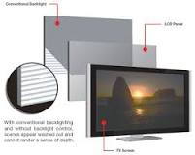](https://www.google.com/search?sxsrf=ALiCzsZqOqocD79gAz2GM6oupxknBUFj7A:1651430866693&q=What+are+the+features+of+LED+TV?&tbm=isch&source=iu&ictx=1&vet=1&fir=Aps8IX97sebxJM%252CAJBflRh-3hCYaM%252C_&usg=AI4_-kSjqPBIEcqwF8catUcw49ayJ1BR-Q&sa=X&ved=2ahUKEwjno7ix-773AhVMzBoKHahhBAAQ9QF6BAgeEAE#imgrc=Aps8IX97sebxJM)“LED TV DETAILS”**

What are the features of LED TV?

**Features of LED backlit LCD TVs**

* An LED TV achieves deeper blacks as well as emitting brighter images, thereby producing better contrast ratios;
* They are slimmer (especially edge-LED lighting systems);
* They deliver better viewing angles than other LCD TVs;
* [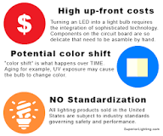](https://www.google.com/search?sxsrf=ALiCzsbGY2pwLGgKVFvkMagnRG87n2e03w:1651430916072&q=What+are+the+disadvantages+of+LED?&tbm=isch&source=iu&ictx=1&vet=1&fir=u8XYLmIYtZe1ZM%252C31Wqea8Yn-1E2M%252C_&usg=AI4_-kQVqo5x4Ihgl8dRP-mijuOJO-wGRQ&sa=X&ved=2ahUKEwjps_TI-773AhVESPEDHcBIAJQQ9QF6BAgLEAE#imgrc=u8XYLmIYtZe1ZM)LEDs are long-lasting;

What are the disadvantages of LED?

**What are the disadvantages of LEDs?**

* High up-front costs.
* Transformer compatibility.
* Potential color shift over lamp life.
* Performance standardization has not yet been streamlined.
* Overheating can cause reduced lamp life.

What are TV types?

**Let us now look into the differences between the various types of televisions by technology resolution and screen by available currently:**

* Liquid Crystal Display (LCD) TV: ...
* [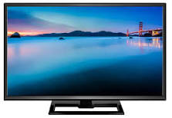](https://www.google.com/search?sxsrf=ALiCzsa5IMP4JOGNxrmmBPkNHxfZgZ-mXg:1651430991063&q=What+are+TV+types?&tbm=isch&source=iu&ictx=1&vet=1&fir=gS9VrwAzgkJX8M%252CFYfOAjxWzn4orM%252C_&usg=AI4_-kR-6VyQKT-GRnVHHUJ2K1_Ft23P7w&sa=X&ved=2ahUKEwj_0dTs-773AhWhSPEDHSZNDX0Q9QF6BAgOEAE#imgrc=gS9VrwAzgkJX8M)Organic Light-Emitting Diode (OLED) TV: ...
* Quantum Light Emitting Diode (QLED) TVs: ...
* Plasma Display Panels: ...
* Digital Light Processing TVs: ...
* 1080p TV:

[More items...](https://stylesatlife.com/articles/different-types-of-televisions/)